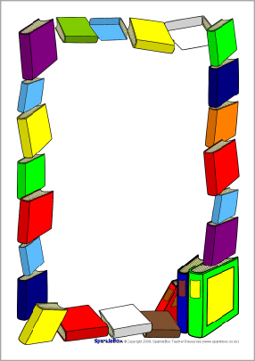

**Spring Story Times**

**\*\*Story times begin at 10:30 a.m.\*\***

**March 9**………………………Spring Theme

**March 23**……………………Earth Day Fun

**April 13**………………………...Easter Theme

**April 27**…………...Police Appreciation

**May 11**………Summer Program Theme

*(Oceans of Possibilities)*